William Selbie

selbiew@oregonstate.edu

CS 457

Link: https://media.oregonstate.edu/media/t/0_bhpj06vq

CS 457 Project #3 – Bumpmapping and Lighting

I added pleats to the square by having the bottom of the square’s z value be the output of a sin function wherein the amplitude is determined by uK as well as the distance of the vertex from the top of the square. This is why the bottom of the square has the most pronounced pleats while the top has none.

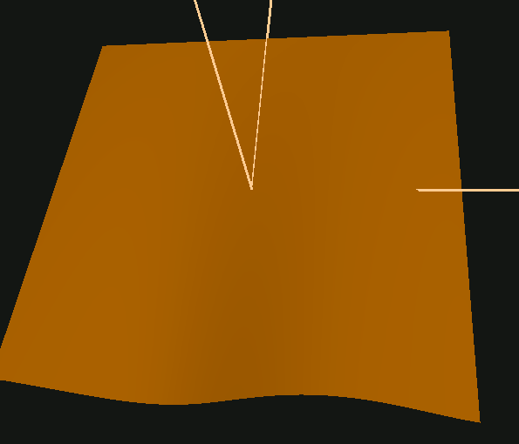 A picture containing object

Description generated with high confidence

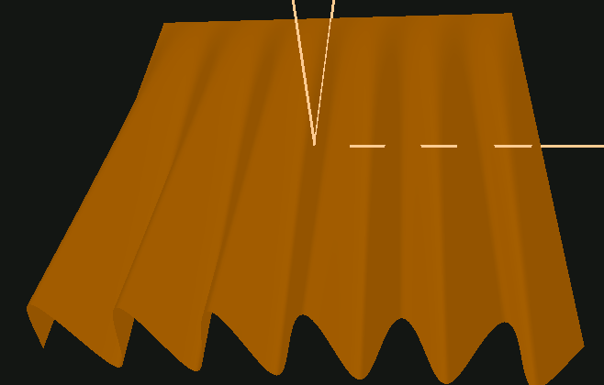 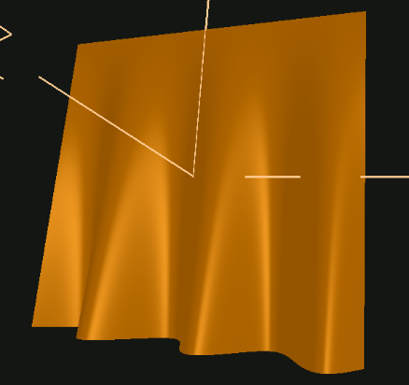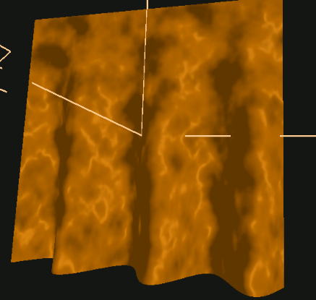

You can see in the first image a square with pleats of low amplitude. To its right is a square with a much higher uK value, increasing the amplitude of the sin wave (pleats). The third image is the square with a low uP (Period), resulting in many pleats. The fourth image shows correct specular lighting (highlights) in the appropriate direction. The light is positioned with a positive x and z, which is why the highlights are where they are. The final image shows the pleated square with noise added to it, which is why it looks as though there’s more going on on the surface than there is. By rotating the normals, it creates “false” highlights and dark areas, giving the impression that the surface at each location is facing a different direction than is actually true.